Selection Sort Algorithm
Selection sort is a sorting algorithm that identifies the smallest element from an unsorted list during each iteration and places that element at the front of the unsorted list.

Working of Selection Sort
- Set the first element as minimum.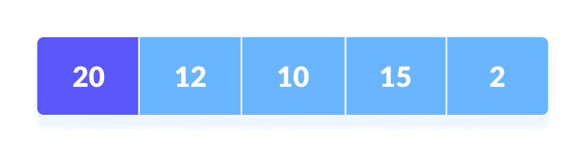Select the first element as the minimum
- Compare the minimum with the second element. If the second element is smaller than the minimum, assign the second element as the minimum.
Compare minimum with the third element. Again, if the third element is smaller, then assign a minimum to the third element otherwise do nothing. The process goes on until the last element.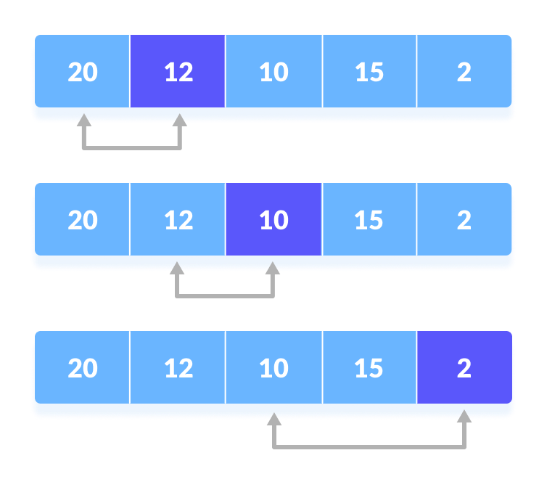Compare the minimum with the remaining elements
- After each iteration, the minimum is placed in the front of the unsorted list.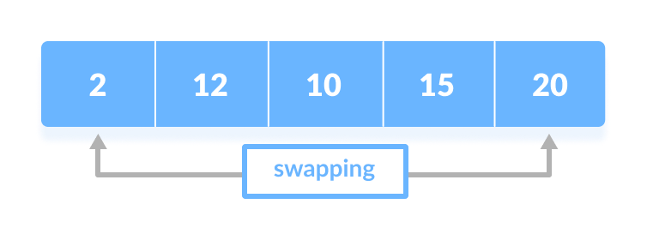Swap the first with a minimum
- For each iteration, indexing starts from the first unsorted element. Steps 1 to 3 are repeated until all the elements are placed in their correct positions.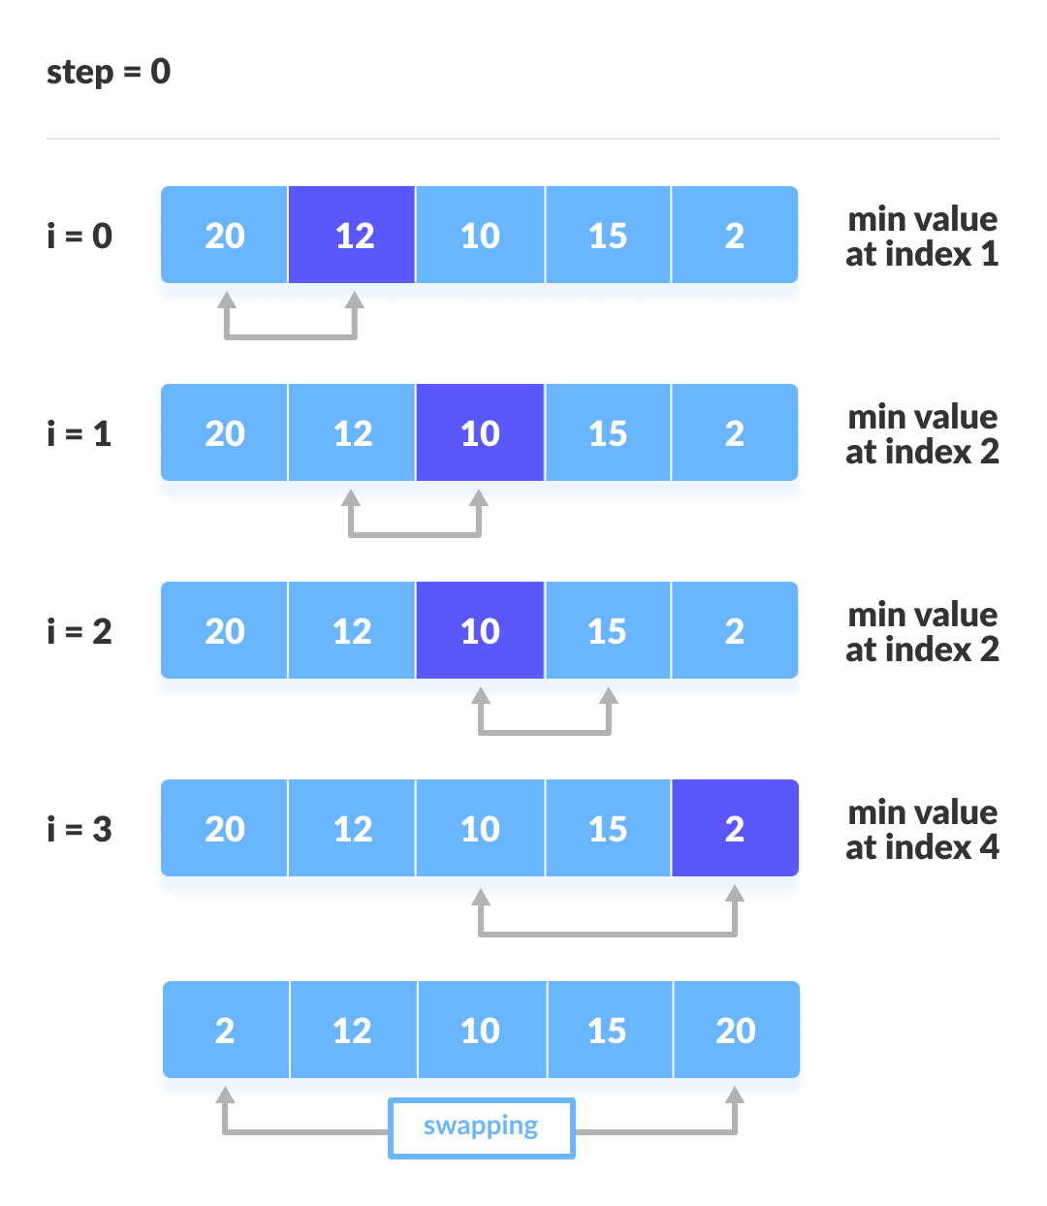The first iteration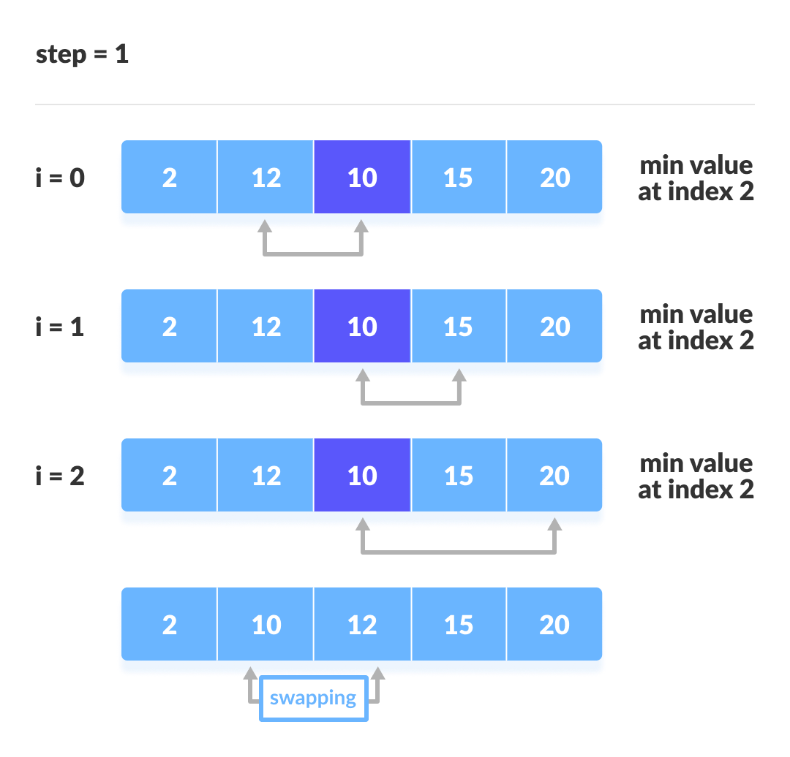The second iteration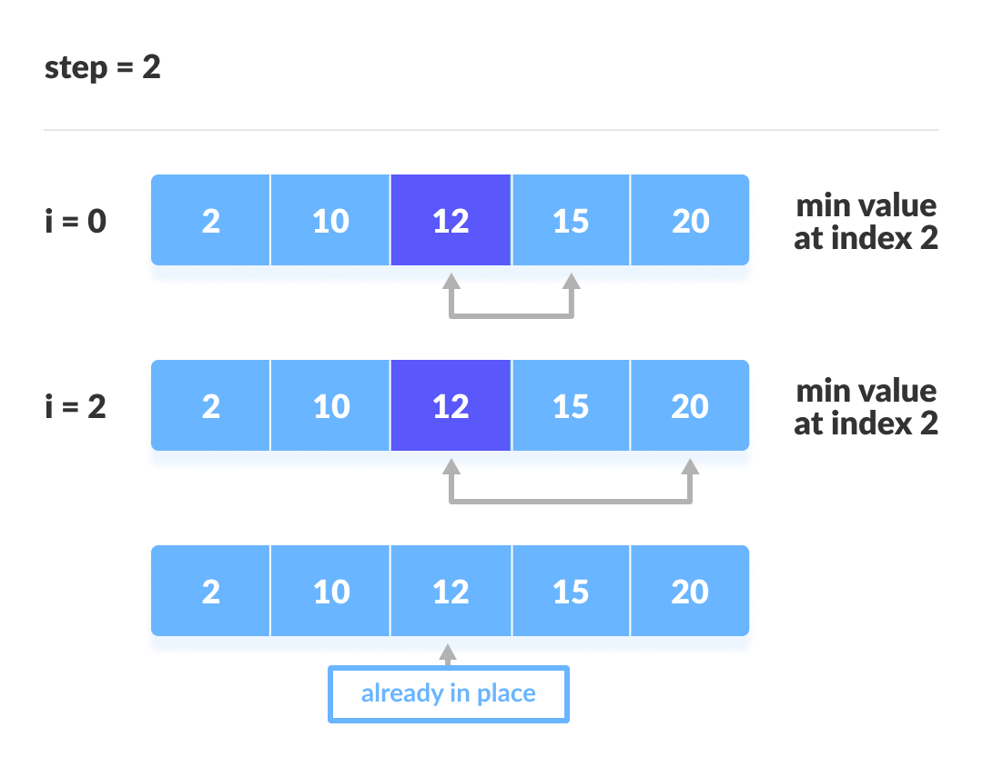The third iteration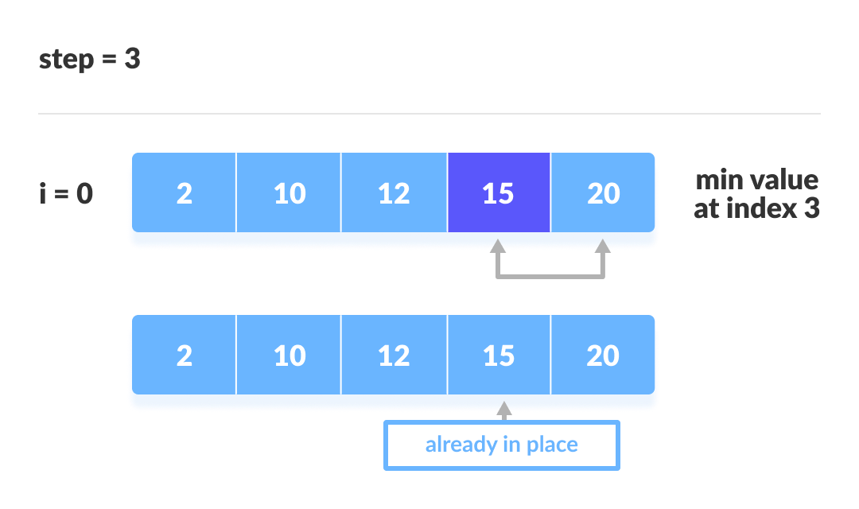The fourth iteration

Selection Sort Algorithm
selectionSort(array, size)
for i from 0 to size - 1 do
set i as the index of the current minimum
for j from i + 1 to size - 1 do
if array[j] < array[current minimum]
set j as the new current minimum index
if current minimum is not i
swap array[i] with array[current minimum]
end selectionSort

Selection Sort Code in Java,
import java.util.Arrays;

class SelectionSort {
void selectionSort(int array[]) {
int size = array.length;

for (int step = 0; step < size - 1; step++) {
int min_idx = step;

for (int i = step + 1; i < size; i++) {

// To sort in descending order, change > to < in this line.
// Select the minimum element in each loop.
if (array[i] < array[min_idx]) {
min_idx = i;
}
}

//Put min at the correct position
int temp = array[step];
array[step] = array[min_idx];
array[min_idx] = temp;
}
}

// driver code
public static void main(String args[]) {
int[] data = { 20, 12, 10, 15, 2 };
SelectionSort ss = new SelectionSort();
ss.selectionSort(data);
System.out.println("Sorted Array in Ascending Order: ");
System.out.println(Arrays.toString(data));
}
}

Selection Sort Complexity
Time Complexity
Best | O(n²)
Worst | O(n²)
Average | O(n²)
Space Complexity | O(1)
Stability | No

Cycle | Number of Comparison
1st | (n-1)
2nd | (n-2)
3rd | (n-3)
... | ...
last | 1
Number of comparisons: (n - 1) + (n - 2) + (n - 3) + ..... + 1 = n(n - 1) / 2 nearly equals to n².
Complexity = O(n²)
Also, we can analyze the complexity by simply observing the number of loops. There are 2 loops so the complexity is n*n = n².
Time Complexities:
- Worst Case Complexity: O(n²)
If we want to sort in ascending order and the array is in descending order then, the worst case occurs.
- Best Case Complexity: O(n²)
It occurs when the array is already sorted
- Average Case Complexity: O(n²)
It occurs when the elements of the array are in jumbled order (neither ascending nor descending).
The time complexity of the selection sort is the same in all cases. At every step, you have to find the minimum element and put it in the right place. The minimum element is not known until the end of the array is not reached.
Space Complexity:
Space complexity is O(1) because an extra variable min_idx is used.

Selection Sort Applications
The selection sort is used when
- a small list is to be sorted
- cost of swapping does not matter
- checking of all the elements is compulsory
- cost of writing to a memory matters like in flash memory (number of writes/swaps is O(n) as compared to O(n²) of bubble sort)

